Marks Distribution:
i. Attendance = 5
ii. Research-based assessment = 5
ii. Quizzes = 15
iii. Assignments = 10
iv. Midterm Exam = 25
v. Final Exam = 40
Total = 100

Details of the assessments:
i. Attendance Policy:
- 70% attendance is a must to sit for the final exam.
- No exception will be allowed without valid documentation.

Marks distribution:
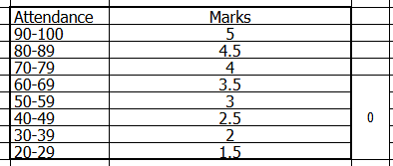
ii. Research-based assessment : This will be a short research based assessment. Details will be shared after mid exam.
- Submission will be central via Turnitin.
- Plagiarism & AI Writing Policy:
- A maximum of 15% similarity is allowed.
- A maximum of 10% AI-generated content is allowed.
Plagiarism and AI scores determined by turnitin will be considered as final. No otherwise will be tolerated.

iii. Quizzes: 4 quizzes; 2 before midterm and 2 after midterm. N-1 will be counted.
Make-Up Quiz Policy:
- There will be only one make-up quiz at the end of the semester.
- Fixed syllabus for the make-up quiz: Chapter 2 (same for all sections).
- Students who miss one or more quizzes with valid documentation may appear in the make-up quiz.
- No additional make-up quizzes will be arranged.

iv. Assignments: 4 assignments; The Average of all the assignments will be counted. Assignments will be shared by respective section faculties.
Late submission policy:
- Cut off time - 6 hours; Suppose deadline is 11:59pm so the cut off time is 5:59am, If a student submits an assignment within cut off time - No penalty.
- Submitting assignment after the cut off time - penalty starts.
- Late submission is allowed up to 1 week after the deadline.
- Late penalty - per day late submission 1 mark will be deducted.
- For late submissions - Students must mention the reason for being late.
- No late submission will be accepted after the faculty shares the assignment solution.

v. Midterm and Final Exam: Details will be shared before the respective exams.

